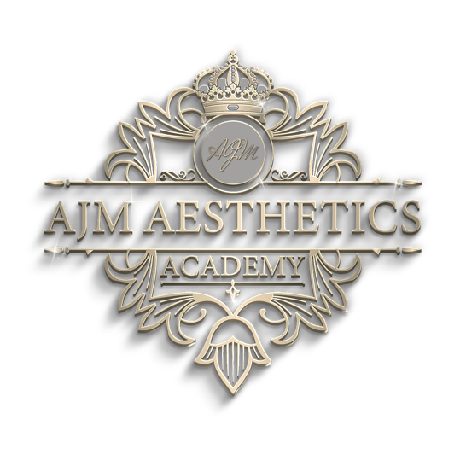

Course Content Review Policy

AJM Aesthetics Academy takes the standard of its courses very seriously. For this reason, the below policy sets out how we ensure the standards of our service is maintained.

Course reviews are an integral part of AJM Aesthetics Academy quality assurance process.

The focus of course reviews is on:

- The appropriateness of the content and assessment method to achieve the learning outcomes,
- The course content being up to date and accurate.

Responsibility

Responsibility for course review and recommendations being addressed rests with the Training & Development Manager. The responsibility for the Review process lies with the company Directors.

Frequency

Each course is reviewed on an annual basis. The courses are reviewed by a Subject Matter Specialist to ensure their accuracy.

All legal elements of the learning materials will be reviewed by the companies Legal Representatives to ensure the most up to date version of any legal references are used and are correct as of the time of the review.

Timing

At the review date, each subject area specialist will have a 30-day period to complete the review of the given subject and all findings reported back to the Training & Development Manager.

The Training & Development Manager will then action any appropriate changes to course materials with an additional 30-day period.

Any legal advice/review related to legal references within the learning materials will be form part of the 30-day review period by the Subject Matter Specialist.

Reporting

Following learning materials & legal review, a detailed report will be provided to the Training & Development Manager, outlining all elements that require addressing and updating.

Name: Amanda Maloney
Position: CEO
Date: 3/3/2023
Signature: A Maloney
Review of Policy: 3/3/2024

